# CS 255 System Design Document Template

## UML Diagrams

### UML Use Case Diagram

*I had forgot to continue my subscription the bubble covered up includes the add / remove class functions and the actor is the owner / administrator*

*

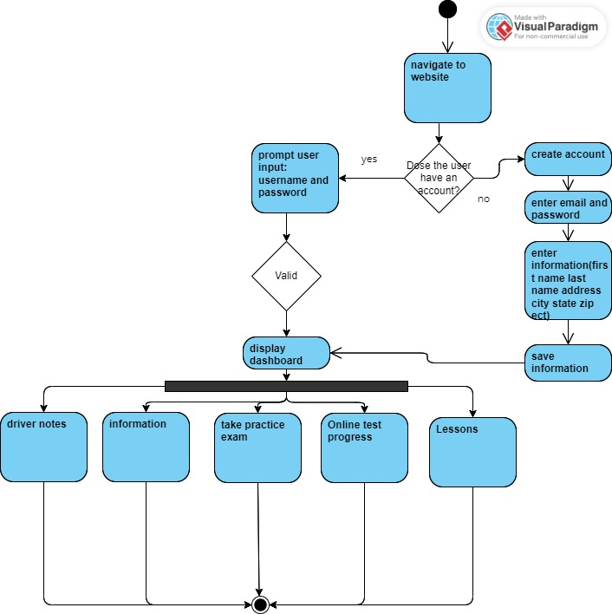

### UML Sequence Diagram

*[You were asked to create a sequence diagram based on* ***one*** *of the use cases you chose. Please insert your sequence diagram here. Check to make sure that you included appropriate components and symbols and that your design meets the client’s needs.]*

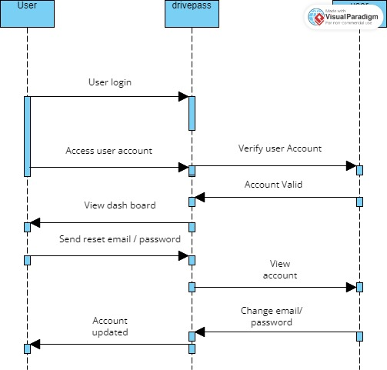

The 3rd category that is covered up is titled user.

### UML Class Diagram

## Technical Requirements

The technical requirements outlined for the DriverPass system are a result of a careful analysis of the project's goals and needs as conveyed during the discussion between the client, consulting company, and project lead. The choice of hardware and server infrastructure, whether physical or cloud-based, derives from the need for reliable hosting and data management to support the envisioned online training platform. The software requirements are designed to align with these objectives, encompassing web servers, databases, and security measures to ensure smooth functionality, data integrity, and protection against potential cyber threats. The proposed use of Docker and containerization technology underscores the importance of streamlined deployment and scalability. The emphasis on user-friendly interfaces, responsive design, and password recovery mechanisms reflects a commitment to providing a seamless experience for clients and their varied devices. Furthermore, the integration with DMV systems underlines the system's relevance and regulatory compliance. Overall, these choices are rooted in the aim to create a robust, accessible, secure, and future-ready system that effectively addresses the void in driver training, aligning technological decisions with the broader strategic vision.

Hardware Requirements:

* Server Infrastructure:
* A dedicated server or cloud-based server(s) to host the system.
* Adequate processing power, memory, and storage to handle user traffic, data storage, and processing requirements.
* Redundancy and failover mechanisms for high availability and data integrity.
* Client Devices:
* Desktops, laptops, tablets, and smartphones capable of accessing the system through web browsers.
* Adequate processing power and memory for smooth user experience.
* Networking Equipment:
* Routers, switches, and firewalls to establish secure and reliable network connections.
* Network cables and Wi-Fi access points for both the server and client devices.
* Peripherals:
* Monitors, keyboards, mice, and other input/output devices for server management and client interaction.
* Software Requirements:
* Server Software:
* Operating system (e.g., Windows Server) for hosting the system.
* Web server software (e.g., Apache, Nginx) for serving web pages to clients.
* Database management system (e.g., MySQL, PostgreSQL) for storing and managing data.
* Security software for protecting against cyber threats and securing sensitive data.
* Docker or similar containerization technology for managing software components and their dependencies.
* Backup and recovery software for safeguarding data.
* Client Software:
* Web browsers (e.g., Chrome, Firefox) compatible with the system's web interface.
* Operating systems (Windows, macOS, Linux) capable of running modern web browsers.
* Development Tools:
* Integrated Development Environment (IDE) for developers to code, test, and debug the system.
* Version control system (e.g., Git) for collaborative development and code management.
* Infrastructure Requirements:
* Cloud Services:
* Cloud-based hosting services (e.g., AWS, Azure) for scalability, easy deployment, and management.
* Load balancing mechanisms to distribute traffic across multiple server instances.
* Database Infrastructure:
* Database servers and clusters for storing and managing application data.
* Data backup and restoration mechanisms to ensure data integrity.
* Security Infrastructure:
* Identity and Access Management (IAM) system for user authentication and authorization.
* Secure Sockets Layer (SSL) certificates for encrypting data transmission.
* Intrusion detection and prevention systems to monitor and respond to security threats.
* Regular security audits and updates to ensure the system's security.
* Interface and User Experience:
* Intuitive and user-friendly web interface with clear navigation and easy access to features.
* Support for responsive design to ensure proper display and functionality on various devices.
* Support for password recovery and reset mechanisms to help users regain access to their accounts.
* Data and Compliance:
* Integration with the DMV's system to receive updates on rules, policies, and sample questions.
* Data encryption for sensitive customer information (e.g., credit card details).
* Mechanisms to track user activity and changes to records for auditing purposes.
* Development and Maintenance:
* Regular maintenance schedule for server updates, security patches, and system improvements.
* Proper documentation of the system's architecture, APIs, and components for future maintenance and development.
* Monitoring tools to track system performance, identify bottlenecks, and ensure optimal user experience.